Personal Portfolio

Release 2

Item 1:

Draft version of the business letter to group 46 that I edited after the first upload.

Item 2:

Login.php is an early tute skeleton of a login page for someone to log in to whatever account on the site.

Item 3:

Register.php is the early tute skeleton of the register page you go to once prompted to register an account. This stores in values input by the user into the users table for the staff database. This also checks for any logic errors such as the username already existing and different password/email repeats.

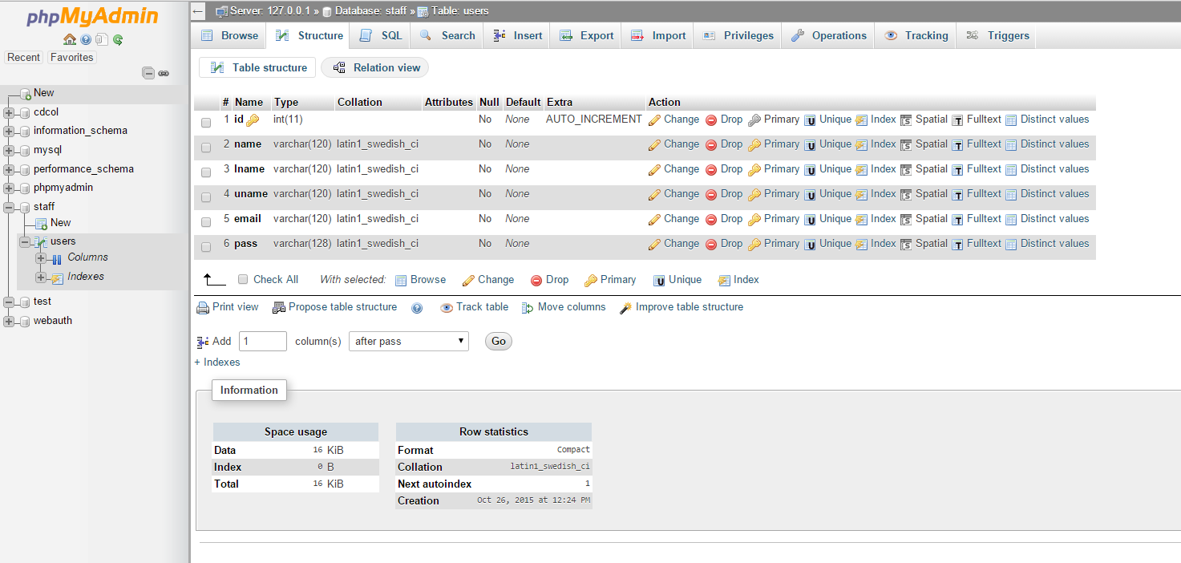

Item 4:

Staff1.php sets up access to the sql server.

Item 5:

Is a draft template of what the register screen on the site should look like.

Harrison Irwin n8816182